**Covid Analysis**

**__________________________________________________**

1. Number of Males: 28690

Number of Females: 21309

1. **Age Distribution**

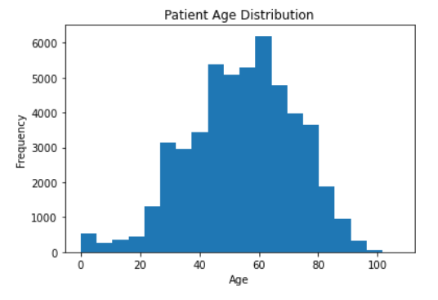

1. **Number of patients with diabetes, hypertension, and intubation:** 2766
2. **Number of pregnant patients with pneumonia:** 33
3. **Percentage of people who are admitted in ICU**

* **Percentage of patients who need ICU admission:** 3.45%
* **Percentage of patients who doesn’t need ICU admission:** 96.54%

1. **Percentage of Covid Status**

* **Percentage of patients who are Covid Positive:** 57.71%
* **Percentage of patients who are Covid Negative:** 42.28%

1. **Percentage of Diabetic Patients:** 27.64%
2. **Proportion of patients who are intubated and have diabetes:** 35.37%
3. **Number of Deaths by Months based on Gender and Patient status**

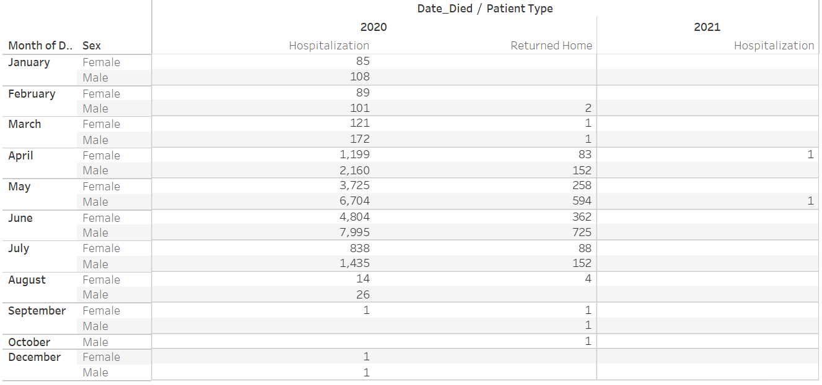

1. **Status of Pregnant women based on Hospitalization and ICU status**

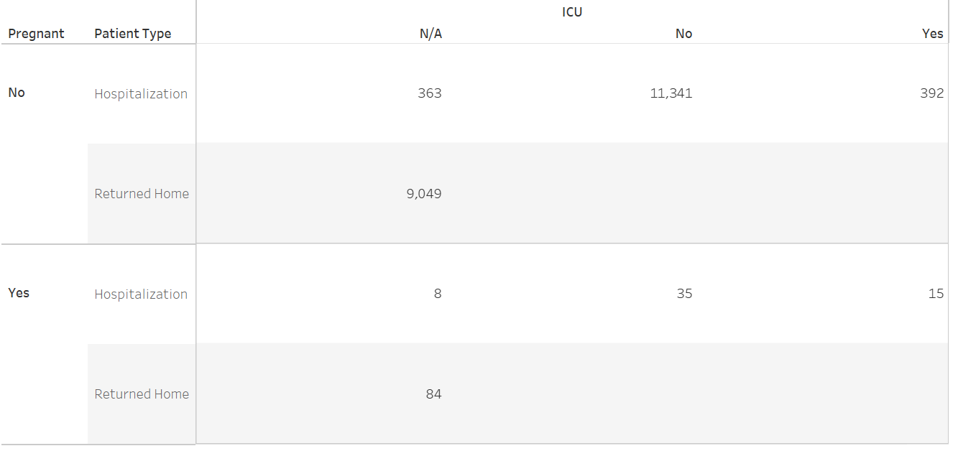

1. **Age distribution of patients who are Intubed**

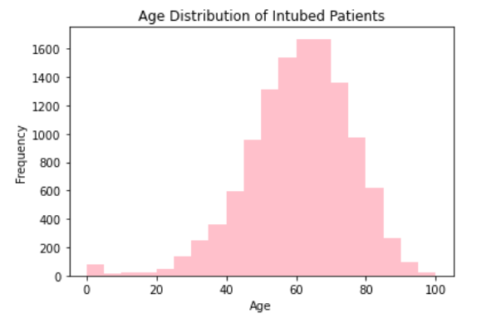

1. **Distribution of patient type in different age groups**

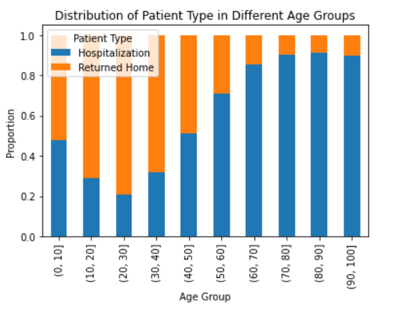

1. **Distribution of Patient sex, type, intubed, pneumonia, diabetes, copd, asthma, hypertension, cardiovascular, obesity, renal chronic, Covid classification, ICU and Other diseases status.**

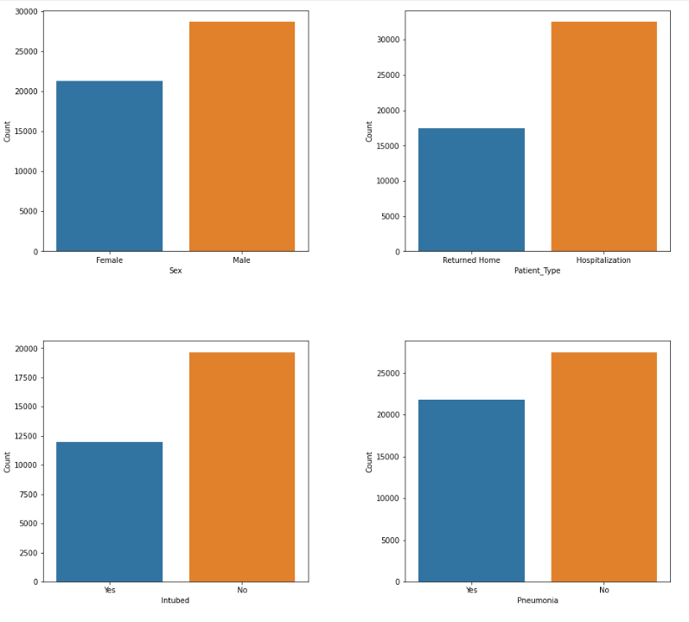

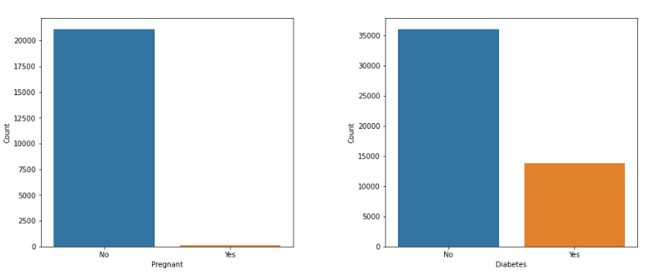

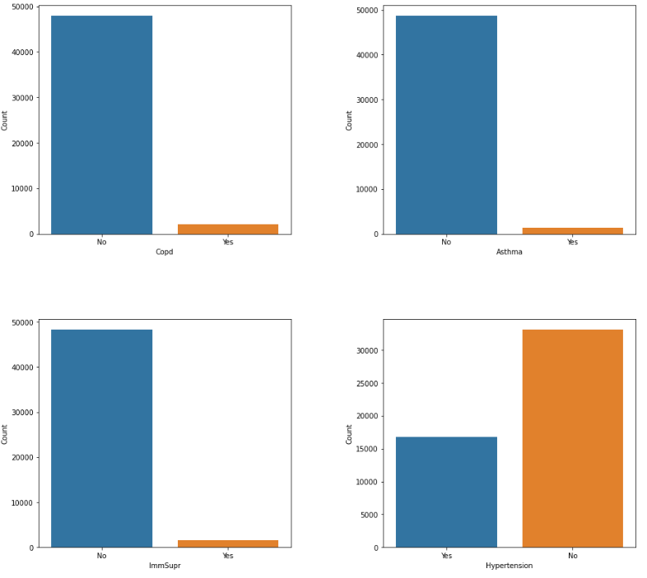

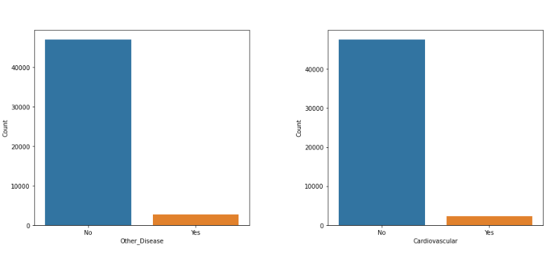

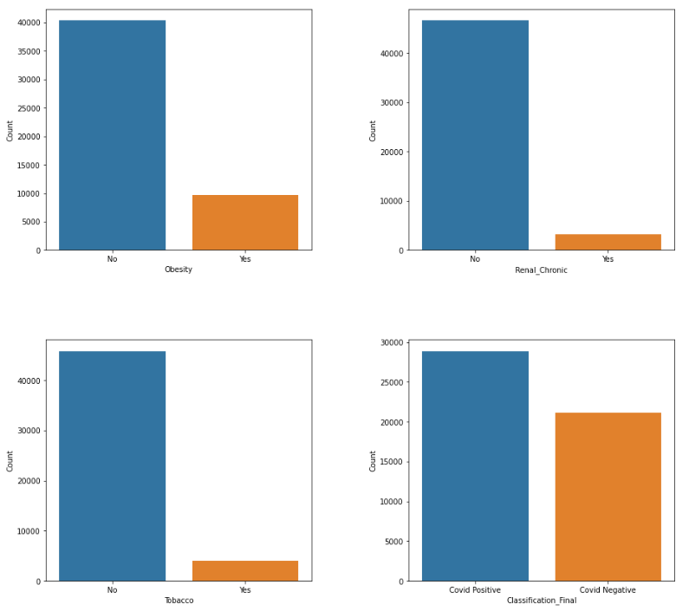

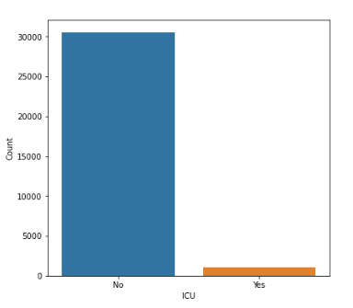

1. **Pie Chart for Percentage of people hospitalized vs Percentage of people returned home**

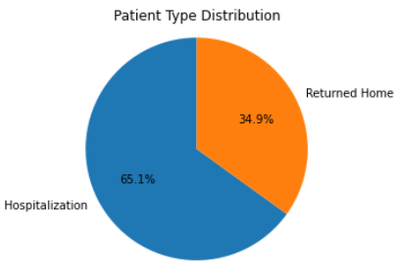

1. **Stacked Bar Chart of Intubation and Pneumonia by Sex**

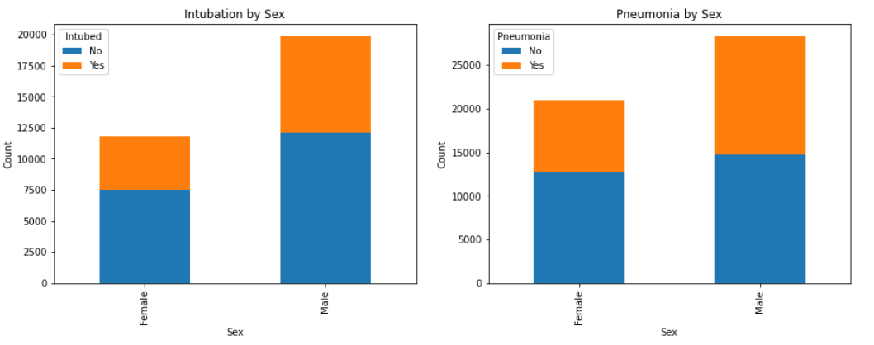

1. **Classification of Covid status by Gender**

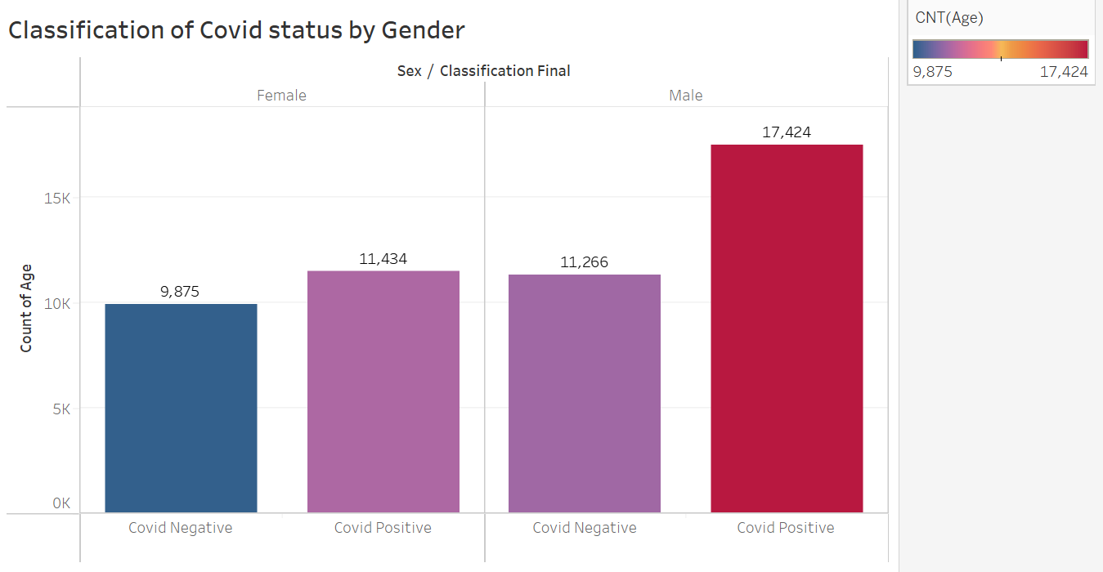

1. **Classification of Patient status by Gender**

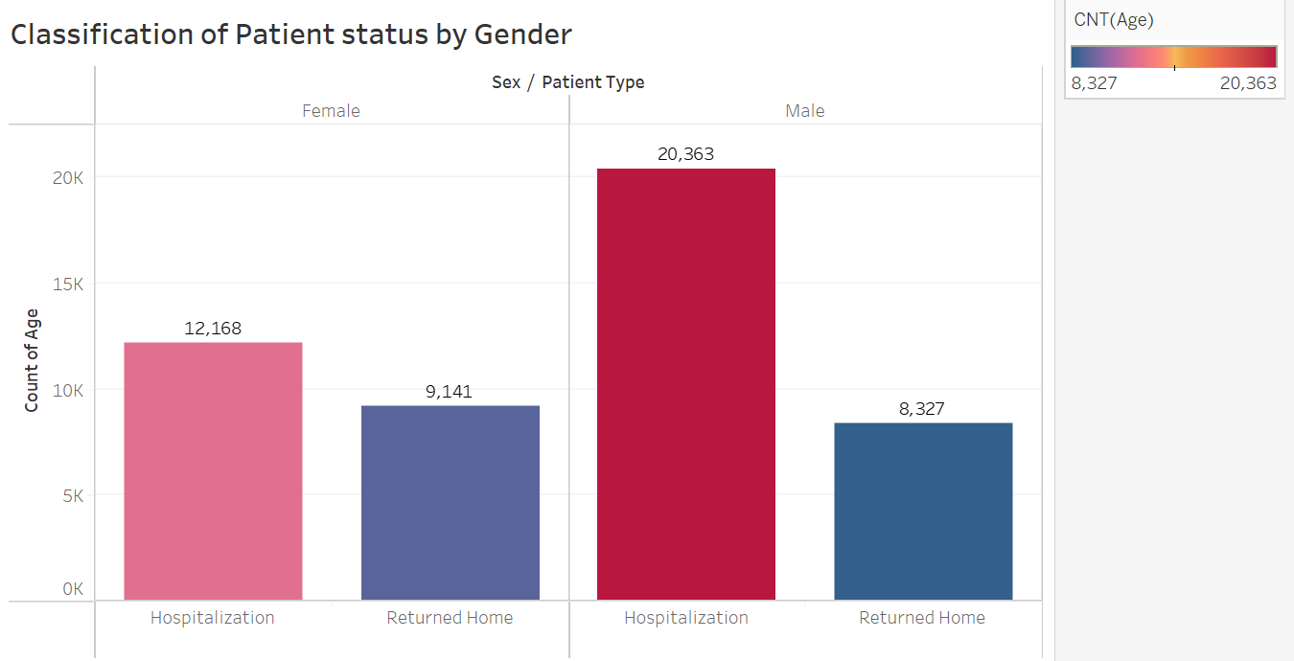

1. **Level of Medical Units (Count) tested in each  institution of the National Health System**

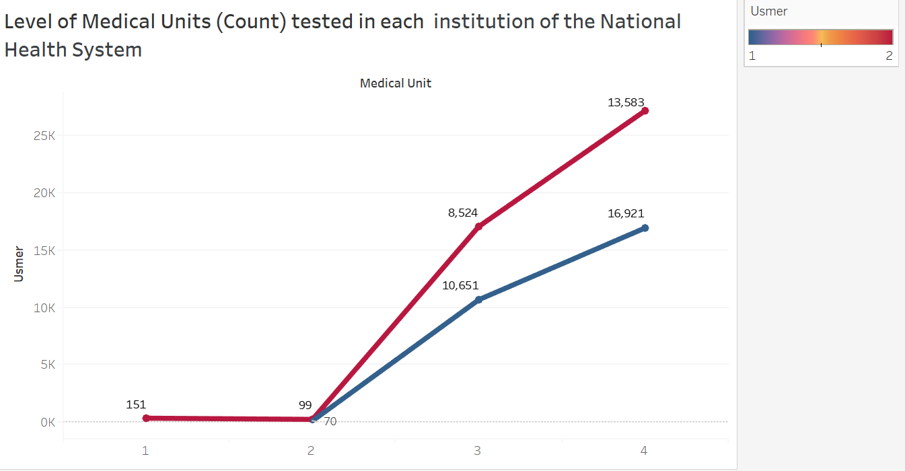

1. **Box Plot of Age distribution by Patient type**

